

Data Technician

Name:
Course Date:
Table of contents
Day 1: Task 1 2
Day 2: Task 1 4
Day 2: Task 2 6
Day 2: Task 3 8
Day 3: Task 1 9
Day 3: Task 2 10
Dataset: 10
Step 1: Create a Pivot Table 11
Step 2: Use the SWITCH Function 11
Submission: 11
Day 3: Task 3 13
Day 4: Task 1 13
Course Notes 17
Additional Information 18

Day 1: Task 1

Please research and complete the below boxes on common laws and regulations that must be followed when working with customers data, use the below bulleted list to support your answers.

- What is it
- Why is it important
- Provide a real-world example of how you can follow it
- How does it impact working with data
- What could happen if you breached it

Data Protection Act | What is it: UK legislation that governs how personal data is used, stored, and protected. It complements the UK GDPR.  Why is it important: It ensures individuals’ privacy rights are respected and that organizations handle data responsibly.  Real-world example: A company encrypts customer data and only allows access to authorized staff.  Impact on working with data: Requires data to be processed lawfully, transparently, and for specific purposes. Staff must be trained in data handling.  Consequences of breach: Fines up to £17.5 million or 4% of global turnover, reputational damage, and legal action
GDPR | What is it: A regulation that sets rules for processing personal data and gives individuals more control over their data.  Why is it important: It strengthens data protection rights and harmonizes standards across the UK and EU.  Real-world example: A website asks for explicit consent before collecting cookies or personal information.  Impact on working with data: Organizations must document data usage, conduct impact assessments, and appoint Data Protection Officers if needed.  Consequences of breach: Severe financial penalties, mandatory reporting to the ICO, and potential lawsuits from affected individuals
Freedom of Information Act | What is it: A law that gives the public the right to access information held by public authorities.  Why is it important: Promotes transparency and accountability in government and public services.  Real-world example: A journalist requests data on council spending, and the council responds within 20 working days.  Impact on working with data: Public bodies must maintain clear records and respond to requests unless exemptions apply.  Consequences of breach: Complaints to the Information Commissioner’s Office, legal challenges, and reputational harm.
Computer Misuse Act | What is it: Legislation that criminalizes unauthorized access to computer systems and data, including hacking and malware distribution  Why is it important: Protects individuals and organizations from cybercrime and ensures digital systems are secure.  Real-world example: An employee avoids accessing files they’re not authorized to view, even if technically possible.  Impact on working with data: Encourages secure access controls, monitoring, and ethical use of IT systems.  Consequences of breach: Criminal prosecution, fines, imprisonment (up to 10 years for serious offenses), and job loss

Day 2: Task 1

Please research and complete the following tasks within the retail-sales_dataset.xlsx document, paste a print screen into the provided boxes below:

- In the sheet ‘retail_sales_dataset’ add all available data between columns A – J into a ‘Table’. Remember to select only the data you want to convert.
- Using the dropdown menu in the ‘Age’ column, sort the data by age, ‘largest to smallest’
- Using the ‘SUM’ function, show me the commission total in cell ‘M10’
- Using the ‘AVERAGE’ function, show me the average commission in cell ‘M11’

Print screen 1 | 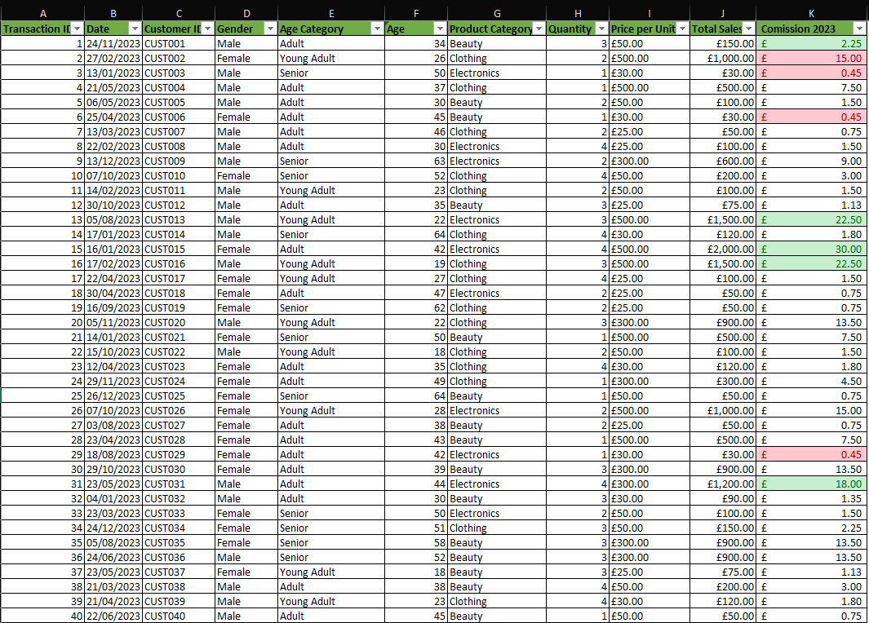
Print screen 2 | 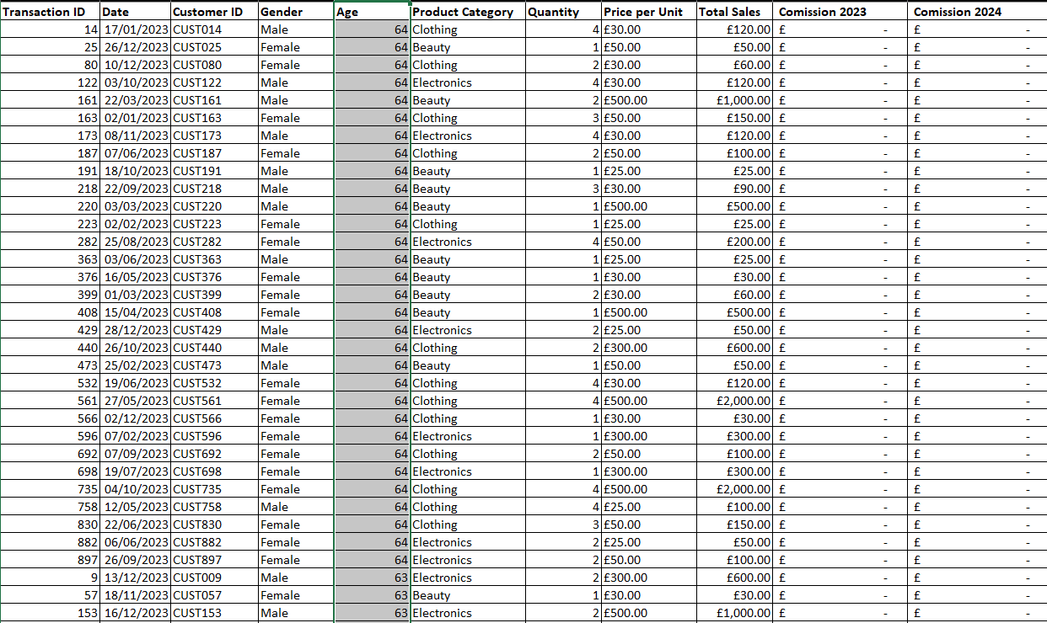
Print screen 3 | 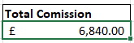
Print screen 4 | 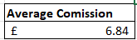

Day 2: Task 2

Please research and complete the following tasks within the retail-sales_dataset.xlsx document, paste print screens into the provided box below:



Print screen 1 | - For Highest English Scores  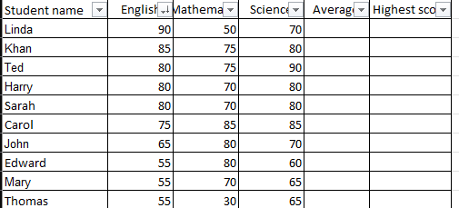  For Highest Mathematics Scores  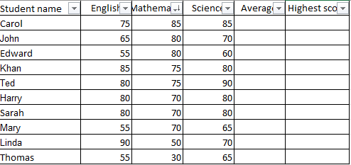  For Highest Science Scores  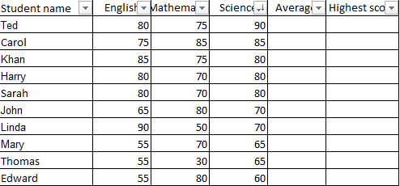  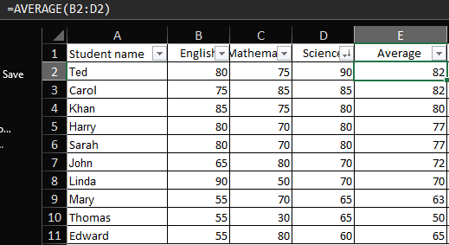  2)  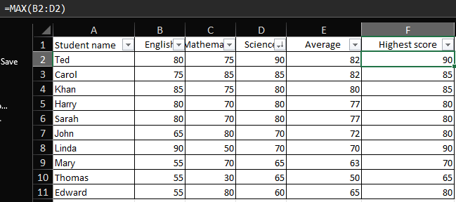  3)  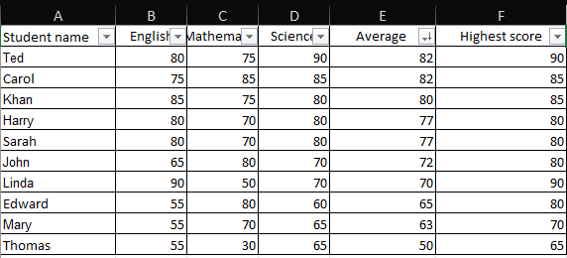  4)  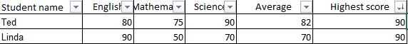  5)  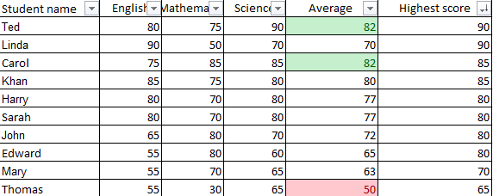  6)

Day 2: Task 3

Using the skills developed today, have some fun with the data set you have imported. Paste your work below and enjoy!

Print screen 1

Day 3: Task 1

Please download the dataset ‘Day_3_Task_1_Bike_Sales_Pivot_Lab.xlsx’ from here.

The lab instructions can be found here. Do not worry if you do not complete the lab, just working with data and playing with the pivot table will be good experience.

Please paste your final pivot table below and complete the reflection questions:

Print screen 1 | 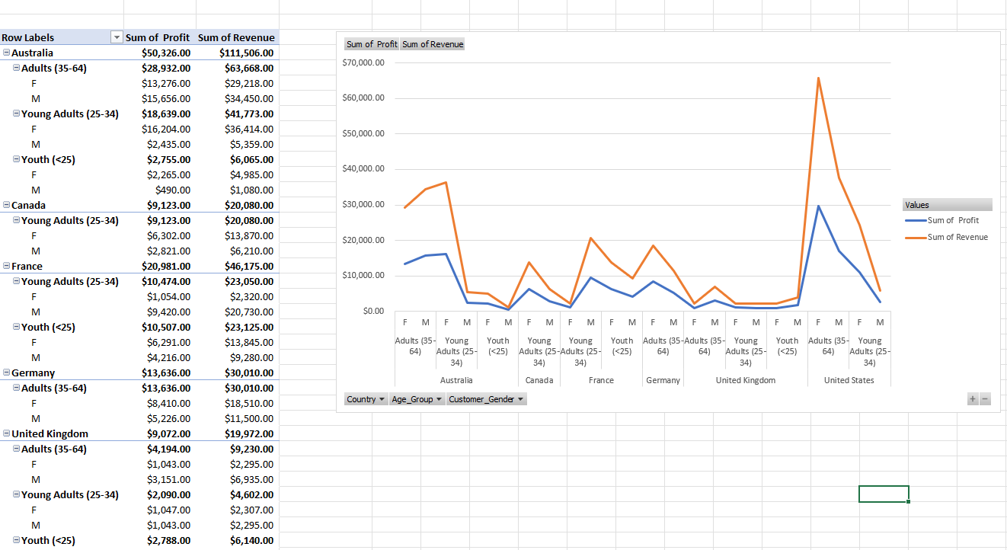  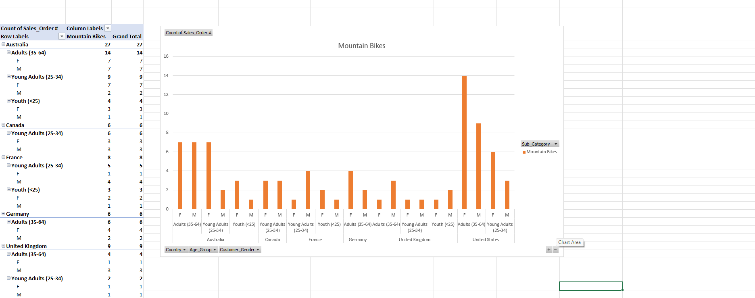
In which markets does Germany have customers? | Germany has a market for Adults aged 35-64
What country has sales in all markets? | The countries that have sales in all markets are Australia and the United Kingdom
What are the most profitable markets by country, age group, and gender? | By country – United States  By Age group – Adults (35-64)  By Gender - Female
Any other findings?

Day 3: Task 2

The dataset below tracks the sales performance of different products in various counties in England. Please paste the dataset into a blank Excel workbook. Your task is to:
- Create a Pivot Table to summarise the data by county and product.
- Use the SWITCH function to categorise products based on their sales volume.

Dataset:
County | Product | Sales Volume
Yorkshire | Laptops | 500
Yorkshire | Smartphones | 200
Cornwall | Laptops | 700
Cornwall | Printers | 400
Lancashire | Smartphones | 150
Lancashire | Laptops | 600
Essex | Printers | 800
Essex | Smartphones | 300
Durham | Laptops | 250
Durham | Printers | 300
Greater Manchester | Smartphones | 600
Greater Manchester | Laptops | 400

Step 1: Create a Pivot Table
- Select the dataset (columns A to C).
- Insert a Pivot Table to summarise the data by County in the rows and Products in the columns. Use Sales Volume as the value to be summarised.

Step 2: Use the SWITCH Function
In a new column next to your data, use the SWITCH function to categorise products based on Sales Volume as follows:
  - For sales greater than 600: "High"
  - For sales between 300 and 600: "Medium"
  - For sales less than 300: "Low"
SWITCH Function Example:
=SWITCH(TRUE, C2 > 600, "High", C2 >= 300, "Medium", "Low")
- Apply this formula to each row, and check if the products are categorised correctly.
- In ‘Sales Volume’ you need to remove the space after each amount
- Confirm the data type is numerical

Submission:
- A completed Pivot Table summarising sales by county and product.
- A new column in the dataset categorising products by sales volume using the SWITCH function.
  - Please paste your completed work below

Print screen 1 | 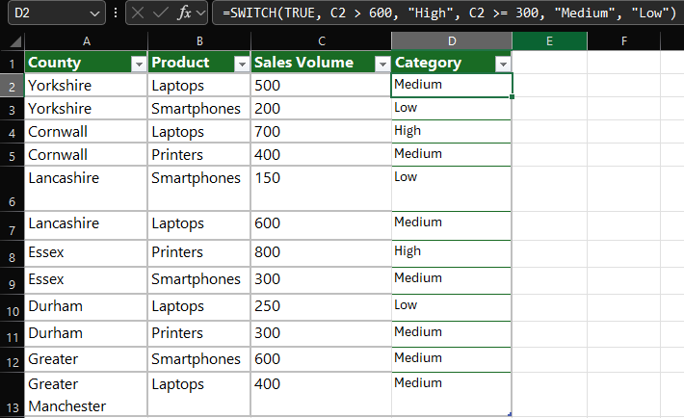  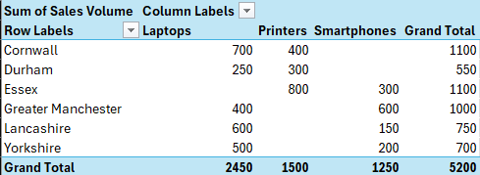

Day 3: Task 3

Please download the dataset ‘Day_3_Task_3_Bike_Sales_Visualisations_Lab.xlsx’ from here.

The lab instructions can be found here. Do not worry if you do not complete the lab, just working with data and playing with the charts will be good experience.

Please paste your results below:

Print screen 1

Day 4: Task 1

You have been asked to deliver your analysis findings to the board of directors, within your analysis you have identified that customers are leaving your company at the 12-month point, this is typically when they receive their renewal price.

Conduct research and complete the below questions:

How would you prepare for the delivery? | To prepare effectively for delivering these findings to a board of directors, I would take a structured, strategic approach focused on clarity, impact, and next steps:  Clarify the Core Message  - Key finding: There is a customer attrition spike at the 12-month renewal point.  - Impact: This is likely tied to pricing perception, renewal communication, or lack of perceived value by that stage.  - Objective for the board: Gain alignment on the severity of the issue and secure support for corrective actions.
What tools would you use for the delivery? | - Powerpoint or google slides as the main deck of the presentation for clean and clear with strategic messaging tailored for executive level attention spans.  - Tableau, Power BI and Excel charts for financial impacts and to display trend lines, simple charts and display figures visually  - Speaker notes to Ensure key messages and data points are delivered concisely without reading slides
What is prospecting and why would you complete this before your delivery? | Prospecting, in this context, refers to the process of informally sounding out key stakeholders or board members ahead of the formal presentation to understand their perspectives, priorities, and potential concerns. It is essentially pre-alignment and intelligence gathering before stepping into the boardroom.
Tell me best practices for public speaking and providing updates to senior leaders | - Speak in short, punchy sentences and land better than long winded explanations  - Link your message to cost, risk and revenue and state the best way to navigate the next steps based on data  - Be upfront with the outcome/conclusion without excess build up  - State if action is required based on everything that has been consolidated
What will you show the board in your delivery? | - I would state the core insight of what’s currently happening and set the tone with relevance  - Display a simple, clean chart showing customer volume over time with a clear drop at month 12  - Highlight the point visually whilst being clear with the underlying  - Discuss the root hypothesis whilst proposing strategic options to mitigate the losses incurred
How will you articulate the changes that are needed? | To articulate the changes needed clearly and persuasively to a board of directors or senior leadership, I would frame them using strategic, commercially aligned language that moves from problem → implication → solution → value gain.
Provide a list of online resources and videos that will support your preparation for public speaking | “The Trick to Powerful Public Speaking” — Lawrence Bernstein (TED)  A short, practical talk on reducing audience-speaker distance.  YouTube  “Chris Anderson: TED’s secret to great public speaking”  Insights from the curator of TED on structure, purpose, and storytelling.  TED  “Julian Treasure: How to speak so that people want to listen”  Focuses on vocal delivery, presence, and being heard.  TED  “The 110 techniques of communication and public speaking” — David JP Phillips (TED)  A deep dive into many micro-techniques you can use in delivery.  TED  “The Secret to Great Public Speaking (No, It’s Not Confidence)” — Jess Ekstrom  On reframing your role as “shining light on others” rather than spotlighting yourself.
Evaluate tools that provide visualisation.  Tell me what they are.  Tell me what you would choose when delivering your presentation and why | Prepare Targeted Data and Insights  - Present retention curve or churn timeline showing the drop clearly at month 12.  - Quantify the financial impact (e.g., “A 10% improvement in 12-month retention could increase annual revenue by £X million”).  - Segment data (if available) by customer type, product, or channel to demonstrate depth of insight.  - Include a brief comparison to industry benchmarks to contextualize the issue.

Course Notes

It is recommended to take notes from the course, use the space below to do so, or use the revision guide shared with the class:

Additional Information

We have included a range of additional links to further resources and information that you may find useful, these can be found within your revision guide.

END OF WORKBOOK

Please check through your work thoroughly before submitting and update the table of contents if required.

Please send your completed work booklet to your trainer.

